Idris Ratlamwala

C31 - 2003145

***Experiment 3*: Programs based on Command-line arguments**

**Theory :**

**Command Line Argument**

**A.**

**Aim :** WAP to accept student’s details via command line and display on the screen.

**Program :**

public class nameRollnoBycmd {

public static void main(String[] args) {

System.out.println("Name : "+ args[0]+ ""+ args[1]);

System.out.println("Roll no : "+ args[2]);

}

}

**Output :**

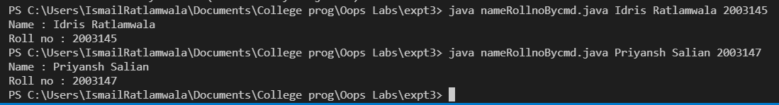

**B.**

**Aim :** WAP to add two numbers accepted via command line .

**Program :**

public class addnumBycmd {

public static void main(String[] args) {

int sum = Integer.parseInt(args[1]) + Integer.parseInt(args[0]);

System.out.println("Sum = "+sum);

}

}

**Output** :

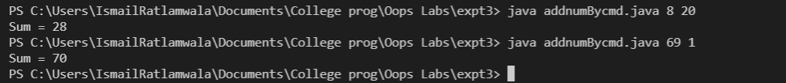

**C.**

**Aim :** WAP to calculate minimum and maximum of three numbers accepted via Command line.

**Program :**

public class maxOf3Bycmd {

public static void main(String[] args) {

int[] n = new int[3];

int max,min;

for(int i=0;i<3;i++){

n[i]= Integer.parseInt(args[i]);

}

max= min= n[0];

for (int i : n) {

max =(i>max) ? i : max ;

min =(i<min) ? i : min ;

}

System.out.println(max +" is largest \n"+min +" is smallest");

}

}

**Output :**

